**Program No: 07**

**Name: Sanio Luke Sebastian**

**Roll No: 35**

**Batch: B**

**Date: 24-05-2022**

**Aim:** Installation of MongoDB on Windows

**Procedure & Outputs:**

* + - 1. download the community server version of mongo db

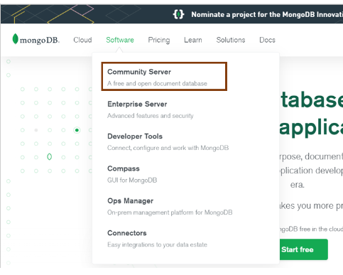

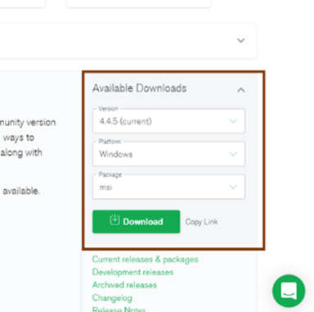

* + - 1. Now, Install the software on your pc

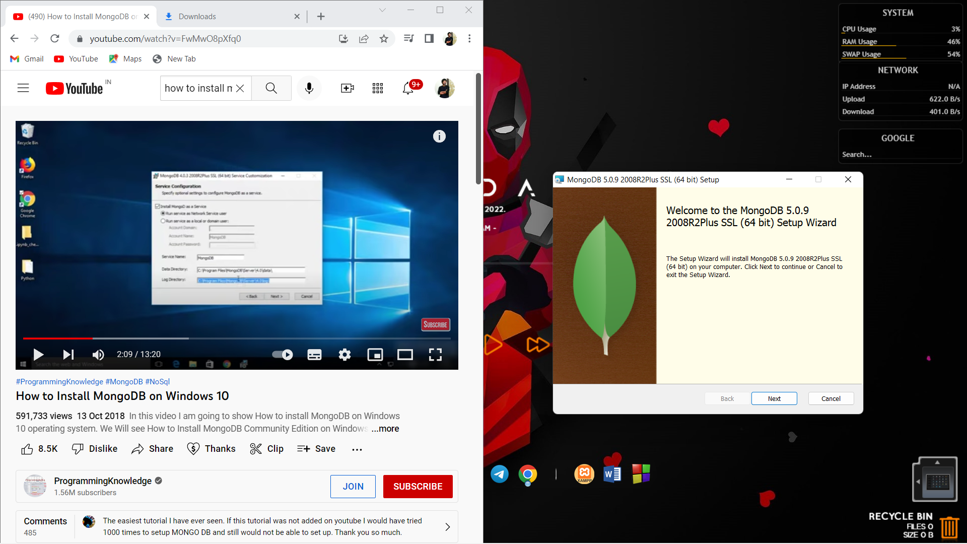

* + - 1. Accept the term and conditions.

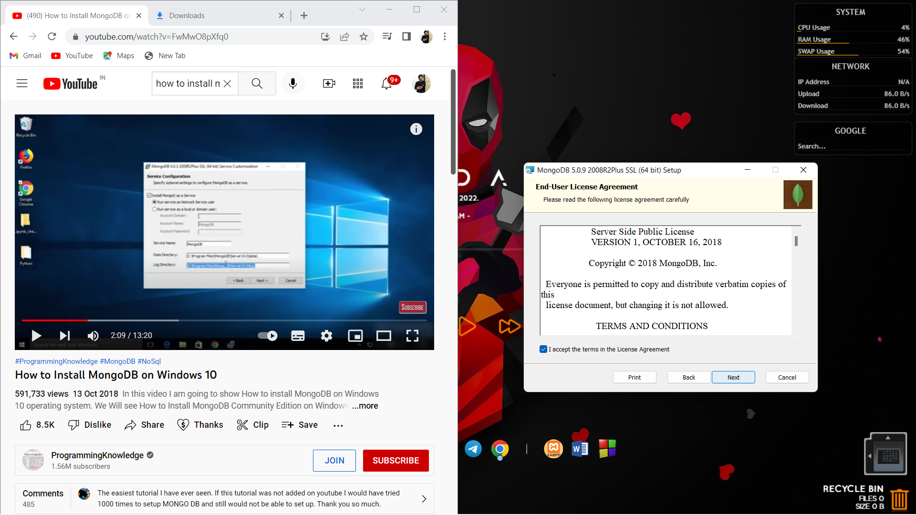

* + - 1. choose service configruation

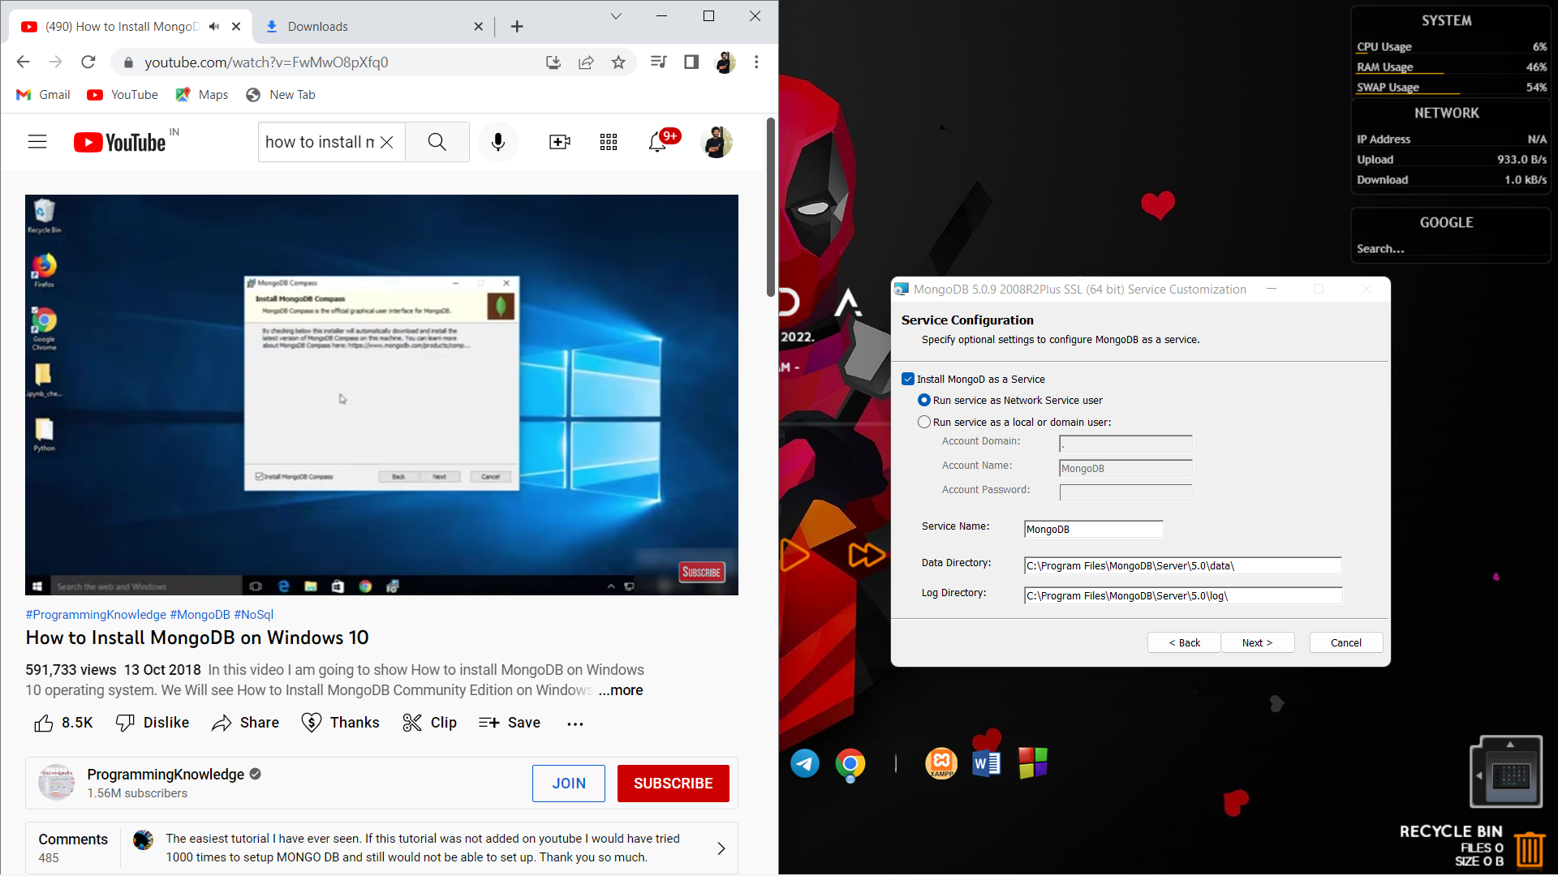

* + - 1. Make necessary changes and install

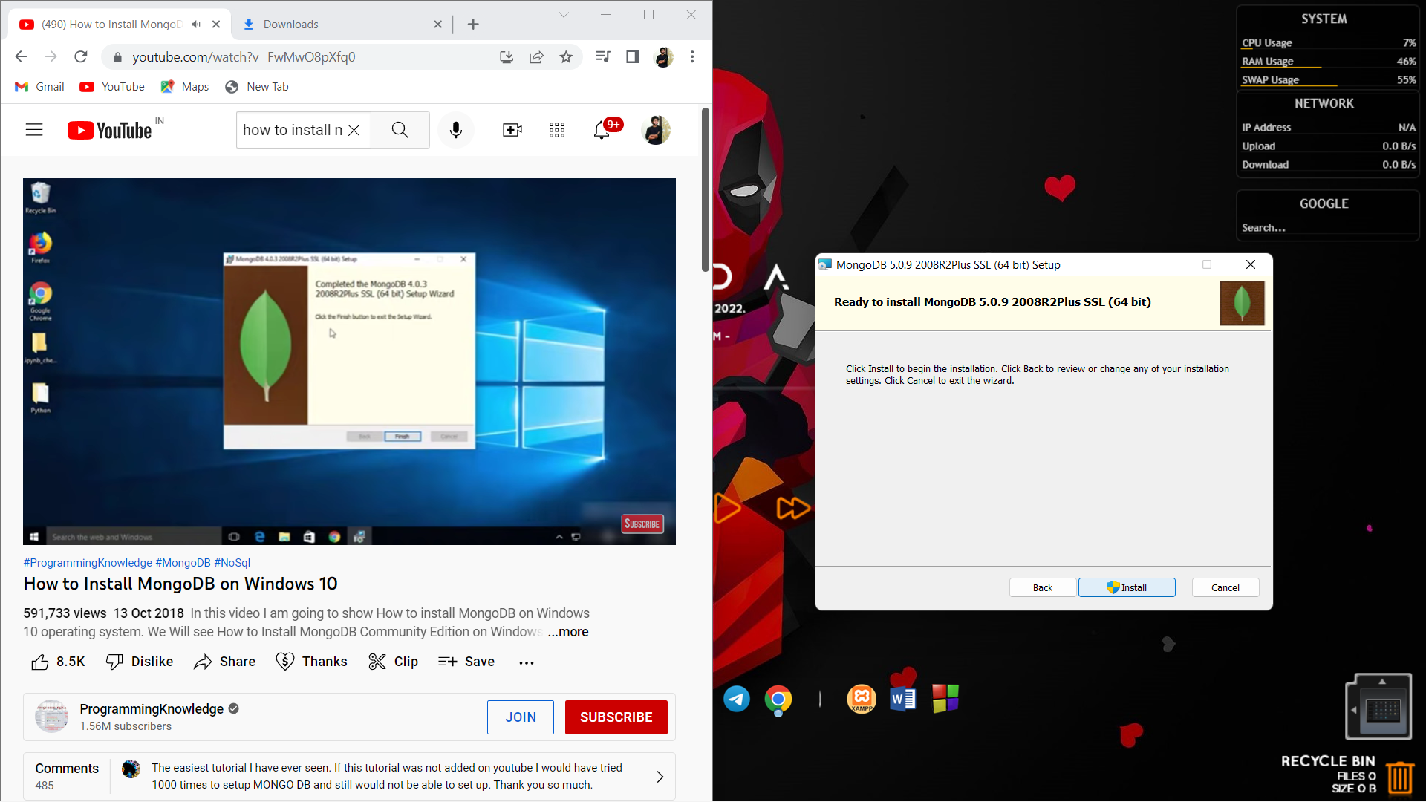

Step 6: verify the installation by typing mongo on cmd

